Sophie Opferman
English 6X
W4
1-22-13

November 1895 was a good time for men.
X-rays were discovered, by Wilhelm Röntgen.

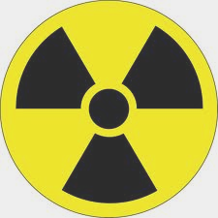
When he discovered them, little did he know,
They were a double-edged sword, like ice or like snow.

What pain he would cause, knew not this gent,
But his research helped discover two new elements.

February 1898, the Curies tested pitchblende.
More rays than uranium, it did lend.

But what did this mean?
From pitchblende, two elements could be gleaned.

Pierre pondered the prenomen of one.
Pondering over, it was called polonium.

Radium glowed, like a twinkle in an eye.
From inside its clutches, many did die.

In 1903, the pair won a prize.
They were ecstatic it was such a surprise.

On April 19, 1906 his story was completed.
In the middle of the road, by a cart he was stampeded.

On Independence Day, 1934, the story ended for her.
She died of radiation poisoning, a brave martyr.

